7.
class Vehicle {
double calculateFee(int hours) {
return hours * 20.0;
}
}

class Car extends Vehicle {
@Override
double calculateFee(int hours) {
return hours * 50.0;
}
}

class TwoWheeler extends Vehicle {
@Override
double calculateFee(int hours) {
return hours * 15.0;
}
}

public class Main {
public static void main(String[] args) {
Vehicle car = new Car();
Vehicle bike = new TwoWheeler();

System.out.println("Car Fee: Rs. " + car.calculateFee(2));
System.out.println("Bike Fee: Rs. " + bike.calculateFee(2));
}
}
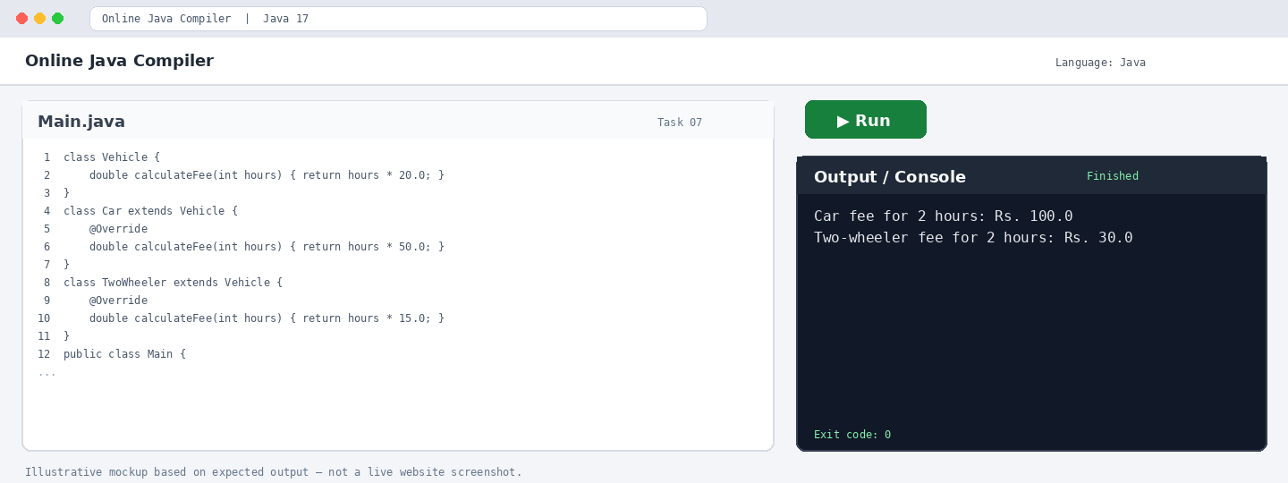
Output

